Handout 1:
Searching and Sorting practice questions:
Q1: Answer the questions for the following scenario.
A bookshop is managing a simple inventory system, storing a book’s title and price. These attributes are stored in Book class. For convenience keep both attributes as public.
class Book
{
public:
string title;
double price;
// Constructor
Book(string title = "UNTITLED", double price = 0) : title(title), price(price) {}
};
SAMPLE main.cpp program.
int main()
{
Book books[] =
{ Book("C++ Programming", 39.99), Book("Data Structures", 29.99), Book("Algorithms", 49.99), Book("Intro to Computer Science", 19.99),Book(), Book("To Kill a Mockingbird", 10.99), Book("1984", 8.49), Book("The Great Gatsby", 12.75), Book("Moby Dick", 15.50), Book("War and Peace", 14.99), Book("Pride and Prejudice", 9.99), Book(), Book("abc alphabets",10.20), Book("1", 20.15), Book("2", 20.35)
};
int size = sizeof(books) / sizeof(books[0]); // Calculate size of the array
return 0;
}

- Write the function selectionSort_ascend, which sorts a list of books by their price in ascending order using selection sort.
- Write the function selectionSort_descend, which sorts a list of books by their price in descending order using selection sort.
- Write the function selectionSort_titles, which sorts a list of books by their titles in ascending order using selection sort.
- Write a function binarySearch. This function will search for a book by its title, return the index if the book is present or return -1 if book is not available. Check for the following book titles:
  - Intro to Computer Science
  - Data StructureS
- Search for books which are priced between 10 and 20 dollars. You should display the book titles which are priced between 10 and 20 dollars.
Check your answers against the following outputs:
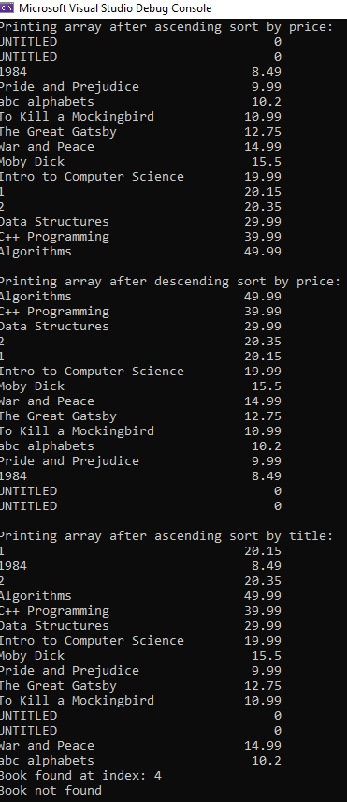
Q2: Copy your solution to Q1 into a new file. Modify this code to make the class attributes private.
Hint: you will need to create setter and getter functions to access title and price. The sorting and searching functions will NOT be member variables.
Q3: Copy your solution to Q1 into a new file. Modify this code to take input from the given “books.txt” file.

